The Florida Department of Transportation’s (FDOT) Office of Inspector General (OIG) provided oversight on 681 ARRA construction and infrastructure projects, totaling more than $1.3 billion. The Inspector General assigned ARRA oversight duties to a specially-formed team which tracked overall progress, ensured consistency and resolved reporting irregularities from districts. Since 2009, the team conducted reviews on approximately 74% of the ARRA projects totaling approximately $998,803,000 of the ARRA dollars. The reviews covered: federal post authorizations; Local Agency Program agreements; department-let construction and consultant contracts; and completed projects. Additionally, the team worked closely with the local Federal Highway Administration Florida Division, Federal Highway Administration National Review Team, Florida Auditor General, United States Department of Transportation’s Office of Inspector General, Office of Management and Budget, and the Government Accountability Office during their reviews.

From the beginning of ARRA, the team tracked activities and reviews conducted by FDOT’s OIG and external oversight agencies as shown on the Florida Inspectors General website: <http://www.floridaoig.com/library/arra_risk_management/dot/DOT_OversightActivities.pdf>

The FDOT OIG monitors weekly department expenditures, shown below.

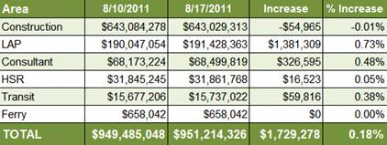

The FDOT OIG develops a monthly “dashboard” of ARRA projects to monitor progress, shown below. This dashboard is provided to the department’s executive management.

